The Last Day of Pompeii

Name
Institution
Instructor
Course
Date

The last Day of Pompeii
The wall painting chosen is Last Day of Pompeii painted belonging to Karl Bryullov. This work of art falls under the historic category having been painted between the years 1827 and 1833. The artist crossed the borders of romanticism and classicism. Thomas (2017) claims that although the painting composition followed the classic law of using trios, the entire essence and content of the picture leaned towards idealism. The painting was not dedicated to a single hero or a specific individual but the entire homeland and chronological events. Additionally, the painting is also remarkable for its positioning between Neoclassicism, Russia's predominant style, and idealism as increasingly practiced in France. Critics in France and Russia noted that the perfection of the classically modeled bodies was out of keeping with their desperate plight and overall theme of the painting which was one of nature's magnificent power to destroy man's creations.
The painting is beautiful, but it is also intricate with each detail followed to perfection. It contains major features that Bryullov expressed not only through using two different light sources but also the icy greenish light originating from the skies and the theatrical red light from the volcano. He was also able to add emotional tension to the painting (The Culture Trip, 2018). Karl Bryullov also went ahead to place himself in the painting, standing next to brushes and paints box. This gesture conveyed his passionate involvement and the emotion in observing the damages caused by the volcano. However, what tops the major features is that he included a real survivor, Plinius, who ran away from Pompeii on time and shared his experience which later led to the creation of the masterpiece.
Notably, this painting is more than just a mixture of oil and color, it is an expression of emotions and sentiments that were felt not only by the painter himself but also I believe by the people of Pompeii that fateful day. Therefore, I settled for this painting because the artist narrated the story through every stroke on the canvas while expressing his emotional involvement placing himself in the masterpiece, which I found appealing and satisfying.
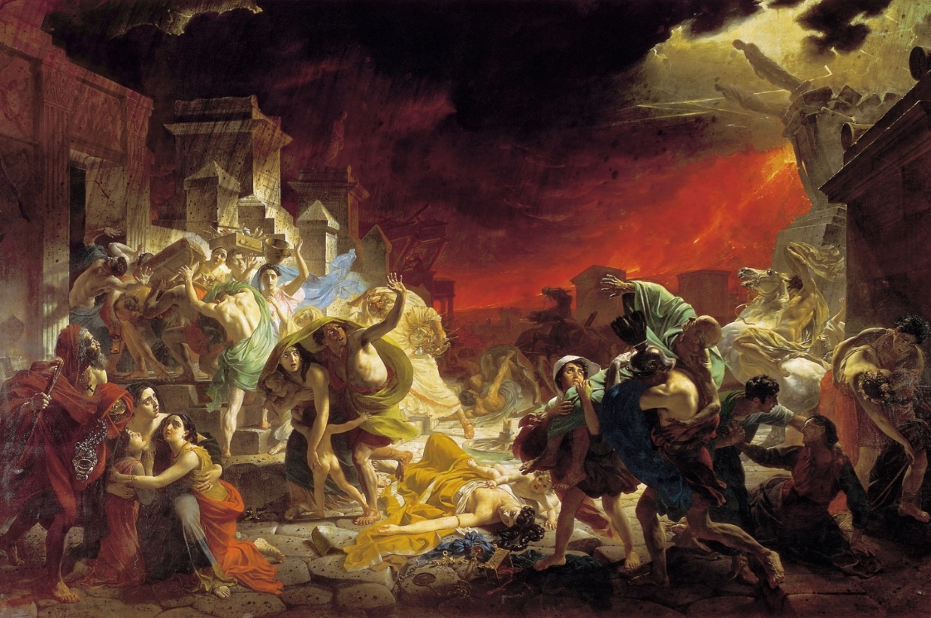
References
The Culture Trip. (2018). History of a Panting: Last Day of Pompeii’ by Karl Bryullov. https://theculturetrip.com/europe/russia/articles/history-of-a-painting-last-day-of-pompeii-by-karl-bryullov/
Thomas, S. (2017). Pompeii, the body, and the imprint of the ancient world. Word & Image, 33(3), 303-312.

